一、Player installation instructions：
1、Unzip the“GvpSetup_map_one.rar”(single video player) or“GvpSetup_map_two.rar” (dual video player: before and rear recording synchronization video), in the "GvpSetup_map_one" or "GvpSetup_map_two" folder to find "GvpSetup.msi", double-click the installation, as follows, complete the installation.
①、The first step：
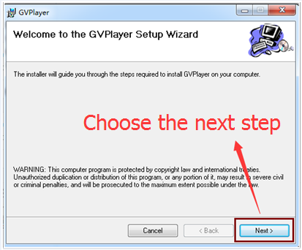
②、The second step：
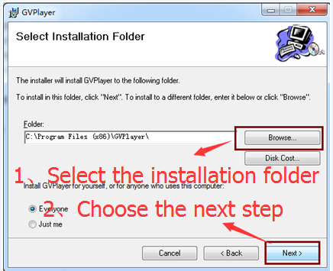
③、The third step：
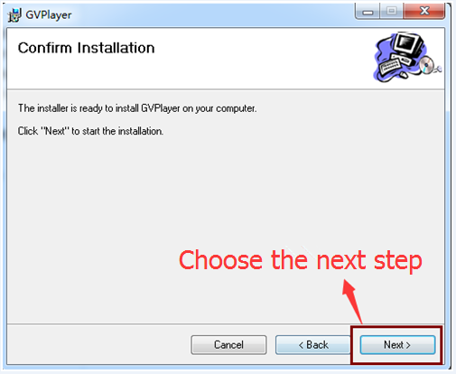
④、The fourth step：
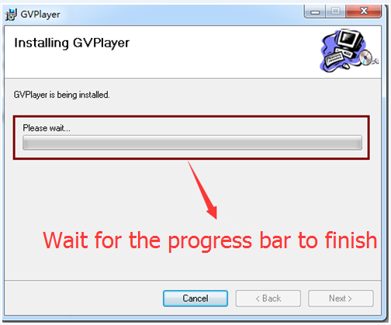
⑤、The fifth step:：
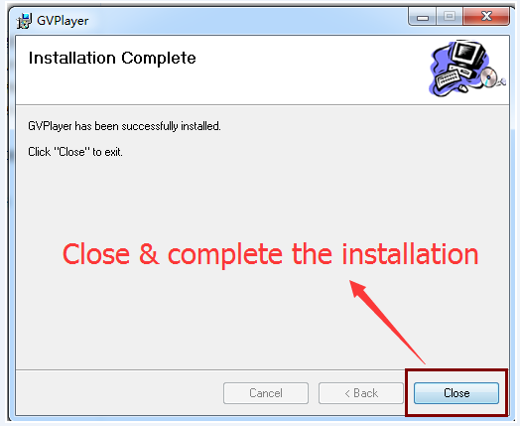
二、Player instructions：
Note: The following example for a single video player, dual video player to add a post-pull playback interface, the other operation and the same as a single video player.
1、Computer desktop to find the player, double-click to open the player.
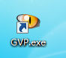
2、Player instructions
Video format is MP4，you can use normal player to check video。
But if you want to check tracking and G-sensor information,please use
Exclusive player。
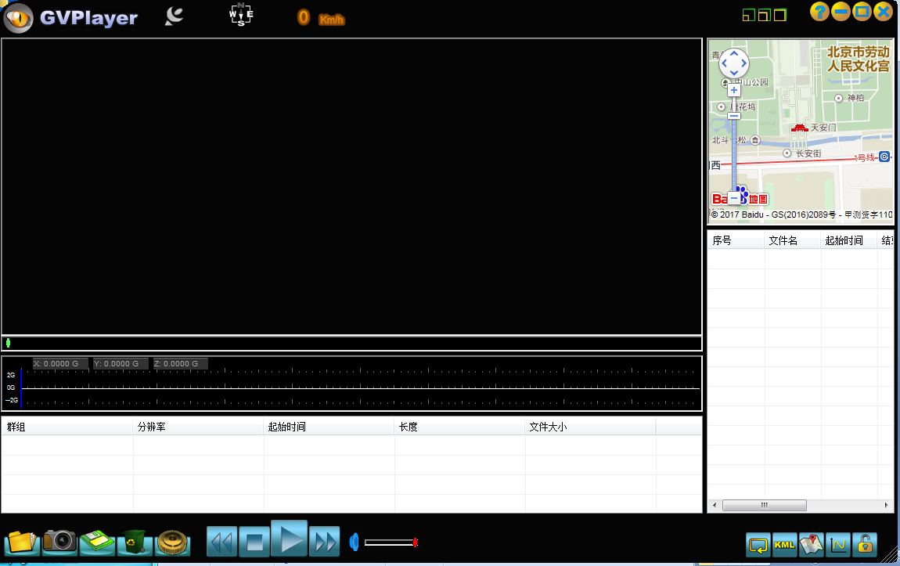
3、Push this button ，you can choose language/map/exit。
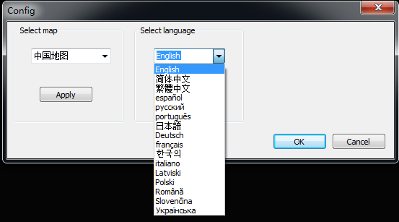
4、Push this button 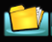 to add choose videos in playlist ：
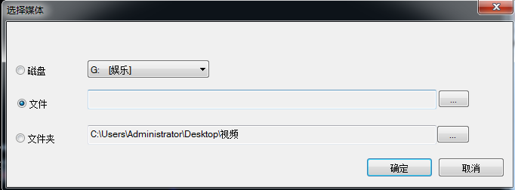
5、Built-in 3G-Sensor, please see following picture, when the three-dimensional X, Y, and Z , any one of them changes, the files with lock are the forced recording videos, this is to protect the videos from being covered. When the car collide with other cars. Analysis the G-sensor can helps to clarify responsibilities
6、Use examples：

